Clemson University

ECE 4130: Computer Vision

Lab 8: Range Image Segmentation

Sarah Anderson

Due: December 3, 2020

**Purpose:**

In this lab, the purpose is to segment a range image based upon surface normals. The student was to use a PPM image called chair-range.ppm and C code regarding conversion of pixels into 3D coordinates and Region Grow (code segments were provided by Dr. Hoover). The segmentation process used the image grid for grouping of pixels, but used the 3D coordinates for calculating the surface normals for region predicates.

**Results:**

**Figure 1**: Original Image

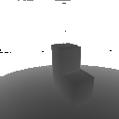

**Figure 2**: Threshold Image at 137

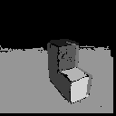

**Figure 3**: Final Image (with angular threshold at 0.65)

**Conclusion:**

Blah